2.1 Use a General Strategy to Solve Linear Equations

Determine whether the values are solutions to the equation 5y + 3 = 10y - 4

a)

b)

A general strategy
- Simplify each side of the equation as much as possible
- Collect all variable terms on one side
- Collect constant terms on the other side
- Make the coefficient of the variable term equal to 1
- Check the solution

Solve
2(m - 4) + 3 = -1

Solve
5(a - 3) + 5 = -10

Solve
10 [3 - 8 (2s - 5) ] = 15 (40 - 5s)
Classifying equations

An equation that is true for one or more values of the variable and false for all other values of the

variable is a ______________________

An equation that is true for any value of the variable is called an _________________

An equation that is false for any value of the variable is called a __________________

Classify the equation as a conditional equation, an identity, or a contradiction and then state the solution
6 (2n - 1) + 3 = 2n - 8 + 5(2n + 1)

4 + 9(3x - 7) = -42x - 13 + 23 (3x - 2)

8 (1 - 3x) + 15 (2x + 7) = 2 (x + 50) + 4 (x + 3) + 1
Solve

Solve

Solve

Solve

Section 2.3 - Solve a Formula for a Specific Variable
Solve for h
V =

Solve for b

Solve for F

Solve for h

Solve for y
4x + 7y = 9
Section 2.5 - Solve Linear Inequalities
Interval notation - always the lower bound then the upper bound (separated by a comma).

We use parentheses or brackets to indicate whether each of the bounds are included in the interval

Brackets mean the bound is included, parenthese mean it is not. The book uses the brackets and parentheses for graphing, but it is common to use closed circles and open circles also

Give the interval notation for the following
1 < x < 5

1 ≤ x ≤ 5

1 ≤ x < 5

x > 4

x < 10

-2 ≤ x

Give the inequality and the interval notation for the following
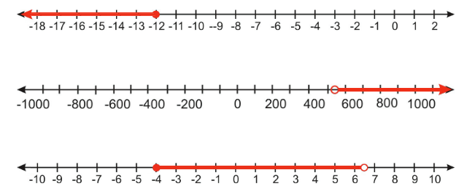
When solving an inequality, we must keep track of the direction of the inequality. It flips if we multiply or divide both sides by a negative number. Also, if we flip the sides: 3 > x is the same as x < 3

Example: Solve, graph, and give the interval notation

Example: Solve, graph, and give the interval notation

Solve, graph, and give the interval notation

Solve, graph, and give the interval notation

Solve, graph, and give the interval notation

Solve, graph, and give the interval notation
6y < 11y + 17

Solve, graph, and give the interval notation
8p + 3 (p - 12) > 7p - 28

Solve, graph, and give the interval notation
8x - 2 (5 - x) < 4 (x + 9) + 6x

Solve, graph, and give the interval notation

Translating into an Inequality
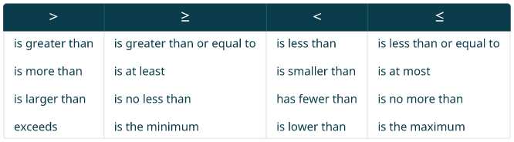
Translate and solve:
Twenty-seven less than x is at least 48

Four more than a is at most 15

Dawn won a mini-grant of $4,000 to buy tablet computers for her classroom. The tablets she would like to buy cost $254.12 each, including tax and delivery. What is the maximum number of tablets Dawn can buy?

Sergio is concerned with his math grade.
He knows that it is computed with the following formula: .4T + .15F + .3H + .15A,
where T is the test average, F is the final grade, H is the homework average, and A is attendance. If he has a 75% on tests, 95% on homework, and 80% on attendance, what grade must he get on the final to receive at least an 80% overall for the class? What grade must he get to get at least a 90% in the class?
Section 2.6 - Solve Compound Inequalities
Consider the compound inequalities:
x + 3 > −4 and 4x−5 ≤ 3
2 (y+1) < 0 or y − 5 ≥ −2
In order for these statements to be true, one or both of the parts must be true

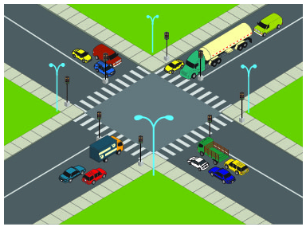
Intersections
To find the solution of a compound inequality with an 'and', we want both parts to be true. We call this the intersection of the two sets

Example: Solve, graph, and give the interval notation
x > -3 and x ≤ 2

Example: Solve, graph, and give the interval notation
6x − 3 < 9 and 2x + 9 ≥ 3

Solve, graph, and give the interval notation
4x − 7 < 9 and 5x + 8 ≥ 3

Solve, graph, and give the interval notation
3x − 4 < 5 and 4x + 9 ≥ 1

Double Inequality: a < x < b is the same as a < x and x < b

Solve, graph, and give the interval notation
−5 ≤ 4x − 1 < 7

Solve, graph, and give the interval notation
−3 < 2x − 5 ≤ 1

Unions
To find the solution of a compound inequality with an 'or', we want either part to be true (or both). We call this the union of the two sets

Example: Solve, graph, and give the interval notation
x < 2 or x > 3

Solve, graph, and give the interval notation
5 − 3x ≤ −1 or 8 + 2x ≤ 5

Solve, graph, and give the interval notation
1 − 2x ≤ −3 or 7 + 3x ≤ 4.

Solve, graph, and give the interval notation
or

Due to the drought in California, many communities have tiered water rates. There are different rates for Conservation Usage, Normal Usage and Excessive Usage. The usage is measured in the number of hundred cubic feet (hcf) the property owner uses.

During the winter, a property owner will pay $24.72 plus $1.54 per hcf for Normal Usage. The bill for Normal Usage would be between or equal to $49.36 and $86.32. How many hcf will he be allowed to use if he wants his usage to stay in the normal range?

Penelope is playing a number game with her sister June. Penelope is thinking of a number and wants June to guess it. Five more than three times her number is between 2 and 32. Write a compound inequality that shows the range of numbers that Penelope might be thinking of
Section 2.7 - Solve Absolute Value Inequalities
Evaluate
- |7|

Evaluate
| -7 |

Solve
|x| = 3

Solve
|x| = 0

Solve
|x| = -3

Example: Solve
|5x - 4| - 3 = 8

Solve
|3x - 5| - 1 = 6
Solve
|4x - 3| - 5 = 2

Solve
2 | x - 7 | + 5 = 9

Solve
3 | x - 4 | - 4 = 8

Example: Solve
| x - 3 | = | 2x + 1 |

Solve
| 5x - 1 | = | 2x + 3 |
Solve Absolute Value Inequalities with "Less Than"
Consider | x | = 5

What would it take for |x| ≤ 5
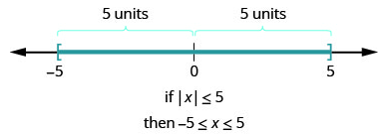

In general, if |u| ≤ a, then -a ≤ u ≤ a

Solve
|x| < 7

Solve
| 5x−6 | ≤ 4

Solve
| 2x−1 | ≤ 5

Challenge: What about
| 2x−1 | ≤ -5

Solve Absolute Value Inequalities with "Greater Than"
Consider |x| = 5

What would it take for |x| ≥ 5
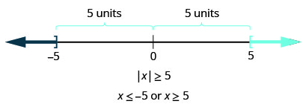

In general, if |u| ≥ a, then x ≤ -5 or x ≥ 5

Solve
|x| > 7

Solve
| 2x−3 | ≥ 5

Solve
| 4x−3 | ≥ 5

Challenge: What about
| 4x−3 | ≥ -5

